Grade 7 Accelerated · Unit 6 · Thread B · Day 1  Angle Pairs: Supplementary, Complementary, Vertical, Adjacent  Question Bank - Additional 6.T1 ANSWER KEY | Name  Date  Period

Show your work. Circle your final answer.
For questions 1 through 4, find the angle.
1. The complement of 43°
47°
90 − 43.

2. The supplement of 151°
29°
180 − 151.

3. The angle vertical to a 66° angle
66°
Vertical angles are equal.

4. The angle that makes a linear pair with a 117° angle
63°
180 − 117.

For questions 5 through 7, find x and the angles.
5. 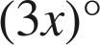 and 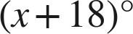 are complementary.
x = 18; 54° and 36°
4x + 18 = 90.

6. 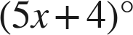 and 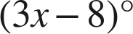 are a linear pair.
x = 23; 119° and 61°
8x − 4 = 180.

7. Vertical angles measure 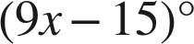 and 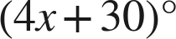.
x = 9; each 66°
5x = 45.

Choose one.
8. Angles E and F are complementary, and angle E is 37°. What is angle F?
○ A. 143°
○ B. 37°
○ C. 127°
● D. 53°
D
90 − 37.

9. Vertical angles measure 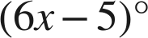 and 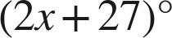. A student answers 8. What did the student find?
● A. the value of x
○ B. the angle
○ C. the complement
○ D. the supplement
A
x = 8; each angle is 6(8) − 5 = 43°.

